WEEK 1

MODULE 4 : MOCKITO EXERCISES

NAME : LOKESHWARAN S
SUPERSET ID : 6742729

Exercise 1: Mocking and Stubbing
Given Scenario:
You need to test a service that depends on an external API. Use Mockito to mock the external API and stub its methods.
Solution:
ExternalApi.java
public interface ExternalApi {
String getData();
}
MyService.java
public class MyService {
private ExternalApi api;
public MyService(ExternalApi api) {
this.api = api;
}
public String fetchData() {
return api.getData();
}
}
3. MyServiceTest.java
import static org.mockito.Mockito.*;
import static org.junit.jupiter.api.Assertions.*;
import org.junit.jupiter.api.Test;
public class MyServiceTest {
@Test
public void testExternalApi() {
ExternalApi mockApi = mock(ExternalApi.class);
when(mockApi.getData()).thenReturn("Mock Data");
MyService service = new MyService(mockApi);
String result = service.fetchData();
assertEquals("Mock Data", result);
}
}

Maven Dependencies (pom.xml):
<dependencies>
<!-- JUnit 5 -->
<dependency>
<groupId>org.junit.jupiter</groupId>
<artifactId>junit-jupiter</artifactId>
<version>5.10.2</version>
<scope>test</scope>
</dependency>
<!-- Mockito -->
<dependency>
<groupId>org.mockito</groupId>
<artifactId>mockito-core</artifactId>
<version>5.12.0</version>
<scope>test</scope>
</dependency>
</dependencies>
Output
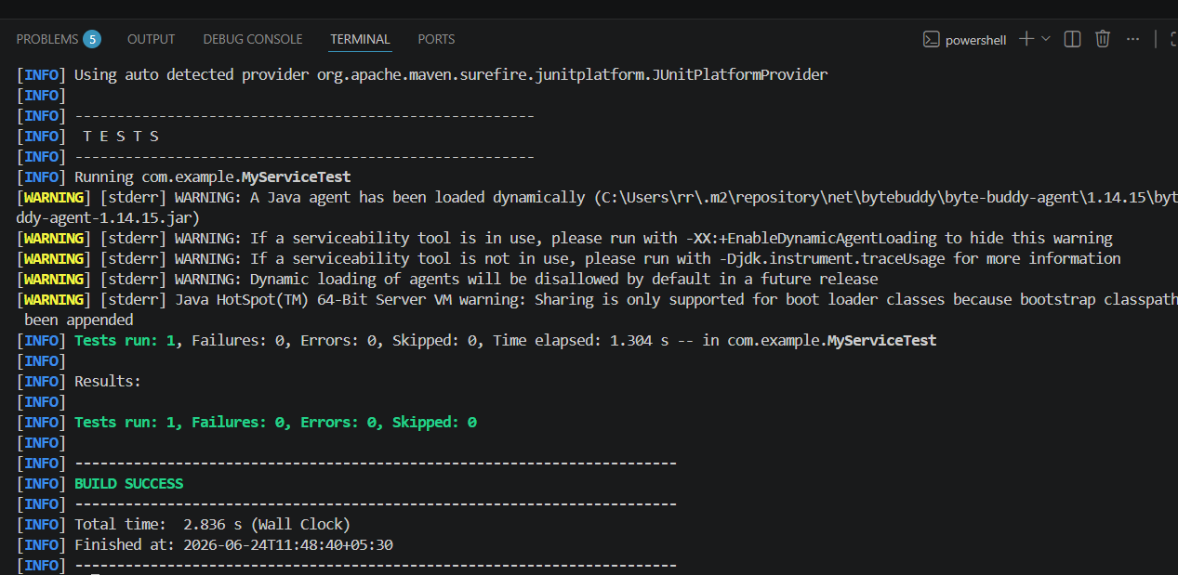
Exercise 2: Verifying Interactions
Given Scenario: You need to ensure that a method is called with specific arguments.
Solution:
ExternalApi.java:
public interface ExternalApi {
void sendData(String data);
}
MyService.java:
public class MyService {
private ExternalApi api;
public MyService(ExternalApi api) {
this.api = api;
}
public void processData(String data) {
api.sendData(data);
}
}
MyServiceTest.java:
import static org.mockito.Mockito.*;
import org.junit.jupiter.api.Test;
public class MyServiceTest {
@Test
public void testArgumentMatching() {
ExternalApi mockApi = mock(ExternalApi.class);
MyService service = new MyService(mockApi);
service.processData("Hello Mockito");
verify(mockApi).sendData(anyString());
}
}

Output:
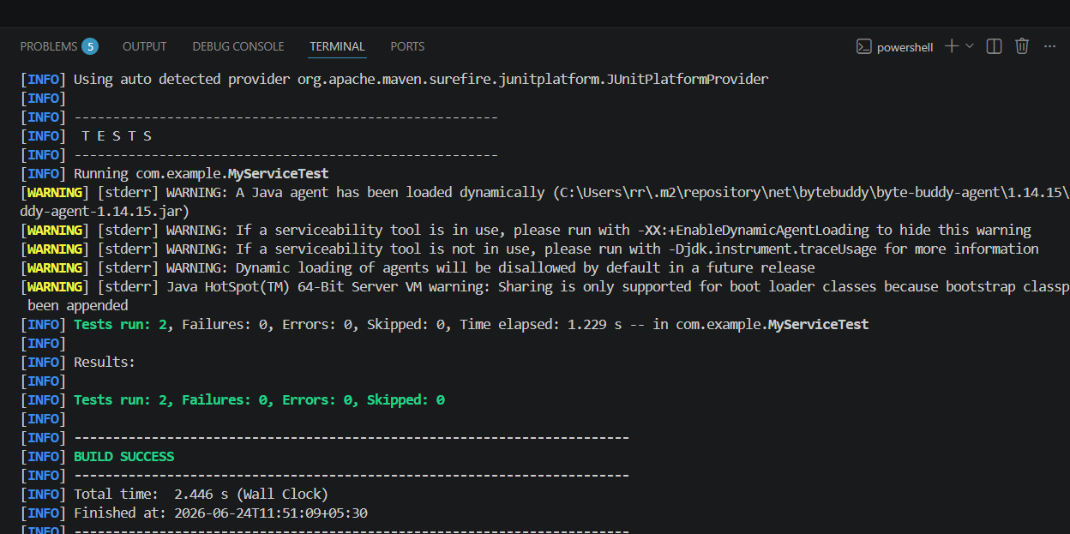

Exercise 3: Argument Matching
Given Scenario: You need to verify that a method is called with specific arguments.
Solution:
ExternalApi.java
public interface ExternalApi {
void sendData(String data);
}
MyService.java
public class MyService {
private ExternalApi api;
public MyService(ExternalApi api) {
this.api = api;
}
public void processData(String data) {
api.sendData(data);
}
}
MyServiceTest.java
import static org.mockito.Mockito.*;
import org.junit.jupiter.api.Test;
public class MyServiceTest {
@Test
public void testArgumentMatching() {
ExternalApi mockApi = mock(ExternalApi.class);
MyService service = new MyService(mockApi);
service.processData("Hello Mockito");
verify(mockApi).sendData(anyString());
}
}

Output:

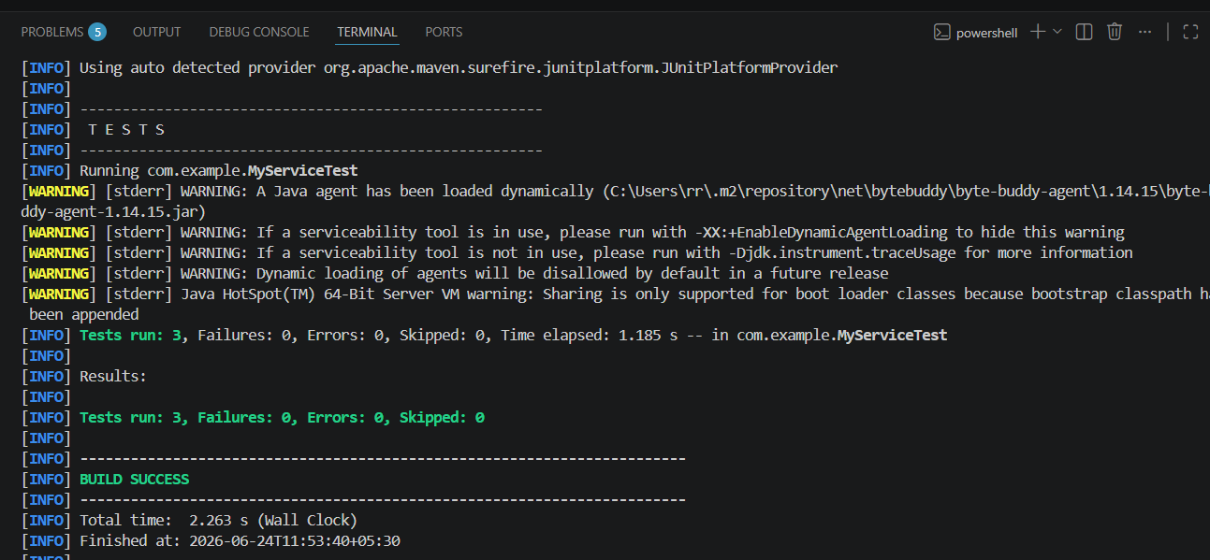

Exercise 4: Handling Void Methods
Given Scenario: You need to test a void method that performs some action.
Solution:
ExternalApi.java
public interface ExternalApi {
void performAction();
}
MyService.java
public class MyService {
private ExternalApi api;
public MyService(ExternalApi api) {
this.api = api;
}
public void executeAction() {
api.performAction();
}
}
MyServiceTest.java
import static org.mockito.Mockito.*;
import org.junit.jupiter.api.Test;
public class MyServiceTest {
@Test
public void testVoidMethod() {
ExternalApi mockApi = mock(ExternalApi.class);
doNothing().when(mockApi).performAction();
MyService service = new MyService(mockApi);
service.executeAction();
verify(mockApi).performAction();
}
}
Output:
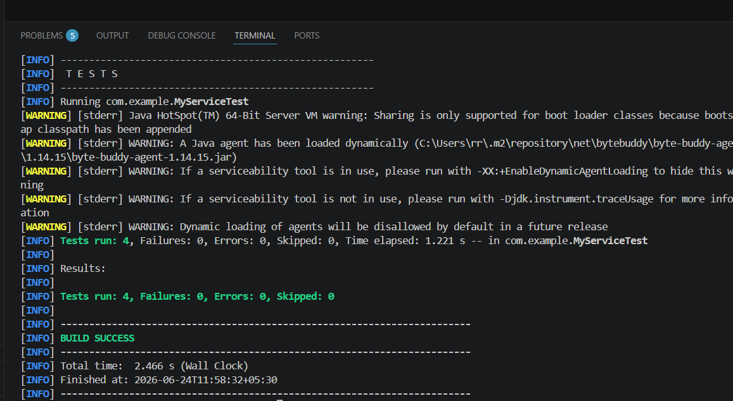

Exercise 5: Mocking and Stubbing with Multiple Returns
Given Scenario: You need to test a service that depends on an external API with multiple return values.
Solution:
ExternalApi.java
public interface ExternalApi {
String getData();
}
MyService.java
public class MyService {
private ExternalApi api;
public MyService(ExternalApi api) {
this.api = api;
}
public String fetchData() {
return api.getData();
}
}
MyServiceTest.java
import static org.mockito.Mockito.*;
import static org.junit.jupiter.api.Assertions.*;
import org.junit.jupiter.api.Test;
public class MyServiceTest {
@Test
public void testMultipleReturns() {
ExternalApi mockApi = mock(ExternalApi.class);
when(mockApi.getData())
.thenReturn("First Call")
.thenReturn("Second Call")
.thenReturn("Third Call");
MyService service = new MyService(mockApi);
assertEquals("First Call", service.fetchData());
assertEquals("Second Call", service.fetchData());
assertEquals("Third Call", service.fetchData());
}
}
Output:
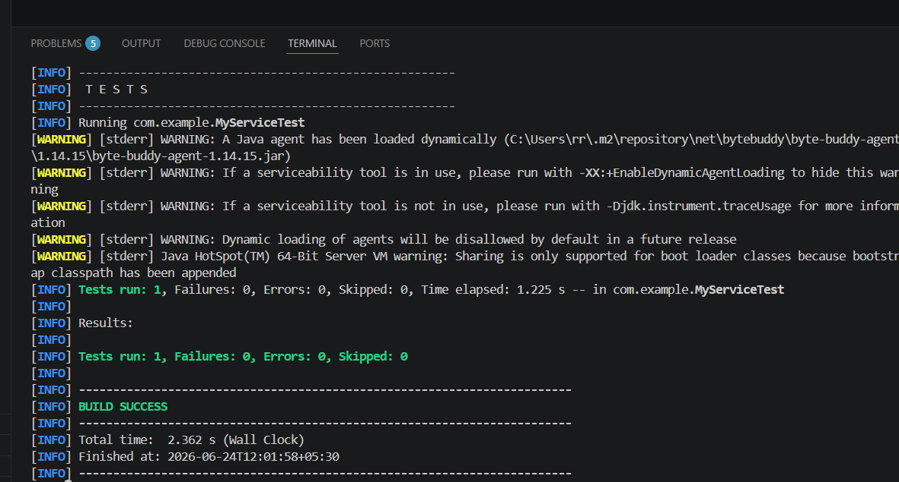

Exercise 6: Verifying Interaction Order
Given Scenario: You need to ensure that methods are called in a specific order.
Solution:
ExternalApi.java
public interface ExternalApi {
void connect();
void getData();
}
MyService.java
public class MyService {
private ExternalApi api;
public MyService(ExternalApi api) {
this.api = api;
}
public void fetchData() {
api.connect();
api.getData();
}
}
MyServiceTest.java
import static org.mockito.Mockito.*;
import org.junit.jupiter.api.Test;
import org.mockito.InOrder;
public class MyServiceTest {
@Test
public void testInteractionOrder() {
ExternalApi mockApi = mock(ExternalApi.class);
MyService service = new MyService(mockApi);
service.fetchData();
InOrder inOrder = inOrder(mockApi);
inOrder.verify(mockApi).connect();
inOrder.verify(mockApi).getData();
}
}
Output:
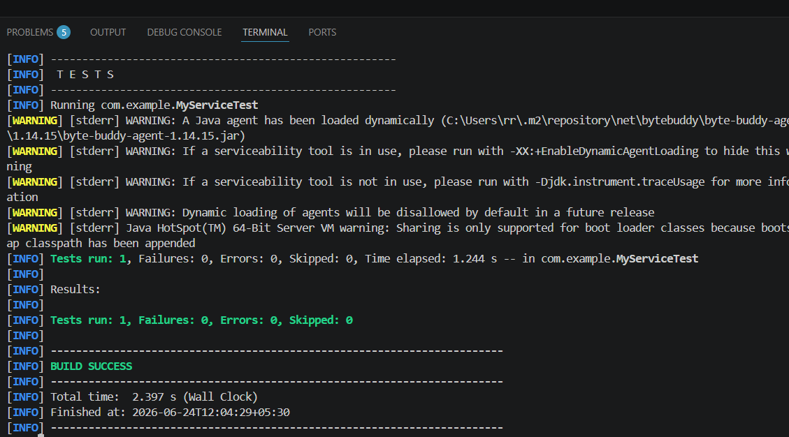

Exercise 7: Handling Void Methods with Exceptions
Given Scenario: You need to test a void method that throws an exception.
Solution:
ExternalApi.java
public interface ExternalApi {
void performAction();
}
MyService.java
public class MyService {
private ExternalApi api;
public MyService(ExternalApi api) {
this.api = api;
}
public void executeAction() {
api.performAction();
}
}
MyServiceTest.java
import static org.mockito.Mockito.*;
import static org.junit.jupiter.api.Assertions.*;
import org.junit.jupiter.api.Test;
public class MyServiceTest {
@Test
public void testVoidMethodException() {
ExternalApi mockApi = mock(ExternalApi.class);
doThrow(new RuntimeException("API Error"))
.when(mockApi)
.performAction();
MyService service = new MyService(mockApi);
assertThrows(RuntimeException.class, () -> {
service.executeAction();
});
verify(mockApi).performAction();
}
}
Output:
